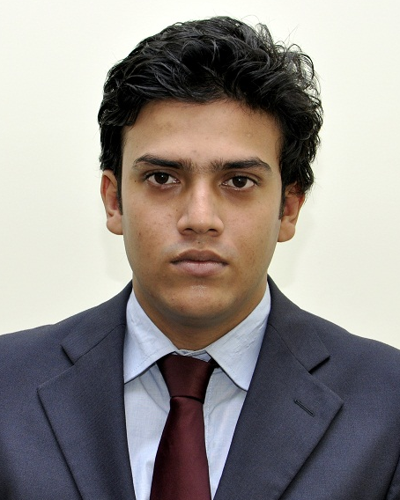

ASIS DATTA
Address:
D/28 Baghajatin,P.O – Jadavpur University, Kolkata-700032.
Contact: 9836452865
Email: asus88@rediffmail.com

Objectives:
- To associate myself with a reputed Organization that will facilitate in my career growth.
- Would like to contribute in the growth of the Organization through my hard work & services.
- Obtain A Position Where I Can Maximize My Management Skills, Quality Assurance, Program Development & Proper Utilization Of Resources

- Working Status: The Waxpol Industries Ltd
Designation: Asst. Executive (Marketing & Communications)
Tenure: June 2016 – Till Date

- Development of annual volume growth and profit objectives by product line for all sales personnel.
- Development of new target markets, products, product lines, marketing programs, and pricing strategies.
- Develop and maintain or improve relationships with key Distributors/Dealer/Sub-Dealers & Customers.
- Analyze all sales data for profitability, product mix, supply and demand trends, and pricing effectiveness.
- Provide market price input and participate in price negotiations with suppliers.
- Supervise the development and dissemination of marketing materials and supplier promotional materials.
- Promote positive relationships with suppliers, partners, vendors, distributors, and customers.
- Work with internal department managers and administrative staff to develop effective internal procedures and lines of communication.
- Provide weekly reports to senior management and attend senior management meetings to review performance and revise strategies.
- Ensure responsibility with Sales Representative accountability/follow-up

- Working Status: Share Khan Ltd.
Designation: Marketing Executive & Portfolio Management
Tenure: August 2013 – May 2016

- Implements marketing and advertising campaigns by assembling and analyzing sales forecasts, preparing marketing
- Evaluate the financial aspects of product development, such as budgets, expenditures, research and development appropriations, and return-on-investment and profit-loss projections.
- Consult with product development personnel on product specifications
- Compile lists describing product or service offerings.
- Coordinate and participate in promotional activities and trade shows, working with developers, advertisers, and production managers, to market products and services
- Conduct economic and commercial surveys to identify potential markets for products and services.
- Updates job knowledge by participating in educational opportunities; reading trade publications.

Educational Details:
Qualification | Board/Council/  University | Name of School/Institute | Marks | Year of Passing
Secondary | W.B.B.S.E | Panchasayar Siksha Niketan | 71% | 2005
Higher Secondary | W.B.C.H.S.E | St. Lawrence High School | 65% | 2007
B.Com(H) (Accountancy) | Calcutta University | South City College | 55.4% | 2010
M.B.A (Marketing & Finance) | West Bengal University of Technology | Future Business School | 7 | 2013

Training:

- Completed ERP on Microsoft Dynamics-Navision from MICRPRO
- Completed Market Research Project from IMRB International under ABACUS Research
- Completed CFA (MOD1) course from Brainware Consultancy Pvt. Ltd.
- Operating System : Windows
- Financial Accounting Packages : TALLY 09, FACT 27.02
- Other Application Software : MS Office.

Other Skills
- Knowledge of Auditing, Financial Analysis, Banking,
- Internship under JAYPEE & CO. (Chartered Accountants) from May’2010 to July’2011

Industrial Visit
Participated in an Industrial Tour to Orissa Cement India Limited (OCL-India Ltd.) at Rajgangpur, Orissa, during September 14 to 16, 2012

Personal Traits
- Hard working
- Committed to responsibilities
- Open to challenges
- Team Player

Interests
- Playing cricket, table tennis
- Listening to music

Personal details:

Date of birth : 26th August 1988
Sex : Male
Marital Status : Married
Nationality : Indian
Languages Known: English, Bengali, and Hindi

Declaration: I hereby declare that the above mentioned details are true to the best of my knowledge.
Place: Kolkata

Asis Datta

